Reinforcement learning
- Difficulty Level : Basic
- Last Updated : 22 Aug, 2022
- Read
- Discuss
Reinforcement learning is an area of Machine Learning. It is about taking suitable action to maximize reward in a particular situation. It is employed by various software and machines to find the best possible behavior or path it should take in a specific situation. Reinforcement learning differs from supervised learning in a way that in supervised learning the training data has the answer key with it so the model is trained with the correct answer itself whereas in reinforcement learning, there is no answer but the reinforcement agent decides what to do to perform the given task. In the absence of a training dataset, it is bound to learn from its experience.
Example: The problem is as follows: We have an agent and a reward, with many hurdles in between. The agent is supposed to find the best possible path to reach the reward. The following problem explains the problem more easily.

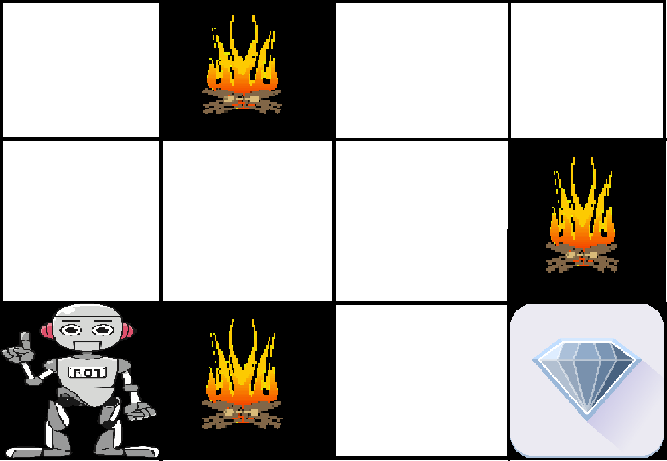
The above image shows the robot, diamond, and fire. The goal of the robot is to get the reward that is the diamond and avoid the hurdles that are fired. The robot learns by trying all the possible paths and then choosing the path which gives him the reward with the least hurdles. Each right step will give the robot a reward and each wrong step will subtract the reward of the robot. The total reward will be calculated when it reaches the final reward that is the diamond.
Main points in Reinforcement learning –
- Input: The input should be an initial state from which the model will start
- Output: There are many possible outputs as there are a variety of solutions to a particular problem
- Training: The training is based upon the input, The model will return a state and the user will decide to reward or punish the model based on its output.
- The model keeps continues to learn.
- The best solution is decided based on the maximum reward.

Difference between Reinforcement learning and Supervised learning:
Reinforcement learning | Supervised learning
Reinforcement learning is all about making decisions sequentially. In simple words, we can say that the output depends on the state of the current input and the next input depends on the output of the previous input | In Supervised learning, the decision is made on the initial input or the input given at the start
In Reinforcement learning decision is dependent, So we give labels to sequences of dependent decisions | In supervised learning the decisions are independent of each other so labels are given to each decision.
Example: Chess game | Example: Object recognition
Types of Reinforcement: There are two types of Reinforcement:
- Positive –
Positive Reinforcement is defined as when an event, occurs due to a particular behavior, increases the strength and the frequency of the behavior. In other words, it has a positive effect on behavior.
Advantages of reinforcement learning are:
  - Maximizes Performance
  - Sustain Change for a long period of time
  - Too much Reinforcement can lead to an overload of states which can diminish the results
- Negative –
Negative Reinforcement is defined as strengthening of behavior because a negative condition is stopped or avoided.
Advantages of reinforcement learning:
  - Increases Behavior
  - Provide defiance to a minimum standard of performance
  - It Only provides enough to meet up the minimum behavior
Various Practical applications of Reinforcement Learning –
- RL can be used in robotics for industrial automation.
- RL can be used in machine learning and data processing
- RL can be used to create training systems that provide custom instruction and materials according to the requirement of students.
RL can be used in large environments in the following situations:
- A model of the environment is known, but an analytic solution is not available;
- Only a simulation model of the environment is given (the subject of simulation-based optimization)
- The only way to collect information about the environment is to interact with it.

GeeksforGeeks Courses

Previous
Markov Decision Process
Next
Supervised and Unsupervised learning
Recommended Articles
Page :
1
2
3
ML | Reinforcement Learning Algorithm : Python Implementation using Q-learning
30, May 19
Genetic Algorithm for Reinforcement Learning : Python implementation
31, May 19
SARSA Reinforcement Learning
14, Jun 19
Introduction to Thompson Sampling | Reinforcement Learning
22, Aug 19
Neural Logic Reinforcement Learning - An Introduction
12, Jan 20
Upper Confidence Bound Algorithm in Reinforcement Learning
08, Feb 20
Expected SARSA in Reinforcement Learning
31, Aug 20
Sparse Rewards in Reinforcement Learning
19, Apr 22
Understanding Reinforcement Learning in-depth
19, Feb 22
Epsilon-Greedy Algorithm in Reinforcement Learning
01, May 20
Introduction to Multi-Task Learning(MTL) for Deep Learning
14, Nov 18
Artificial intelligence vs Machine Learning vs Deep Learning
23, Jan 19
Learning to learn Artificial Intelligence | An overview of Meta-Learning
18, May 19
Difference Between Artificial Intelligence vs Machine Learning vs Deep Learning
01, May 20
Need of Data Structures and Algorithms for Deep Learning and Machine Learning
14, Oct 20
Collaborative Learning - Federated Learning
20, Jan 21
Fusion Learning - The One Shot Federated Learning
20, Jan 21
ML | Types of Learning – Supervised Learning
01, May 18
How to Start Learning Machine Learning?
11, Sep 19
Learning Model Building in Scikit-learn : A Python Machine Learning Library
17, Feb 17
Demystifying Machine Learning
02, May 16
Cross Validation in Machine Learning
21, Nov 17
How To Use Classification Machine Learning Algorithms in Weka ?
04, May 21
Support vector machine in Machine Learning
20, Dec 20
Article Contributed By :

Prateek Bajaj
@Prateek Bajaj
Vote for difficulty
Current difficulty : Basic
Improved By :
- Sharath Chandra 1
- frikishaan
- parthvin
- punamsingh628700
Article Tags :
- Advanced Computer Subject
- Machine Learning
Practice Tags :
- Machine Learning

Report Issue

Data Structures & Algorithms- Self Paced Course
View Details
AD

AD

What's New


Machine Learning Foundation - Self Paced
View Details

Complete Interview Preparation- Self Paced Course
View Details

AD

AD

AD

ML | Reinforcement Learning Algorithm : Python Implementation using Q-learning
- Difficulty Level : Hard
- Last Updated : 07 Jun, 2019
- Read
- Discuss
Prerequisites: Q-Learning technique.
Reinforcement Learning is a type of Machine Learning paradigms in which a learning algorithm is trained not on preset data but rather based on a feedback system. These algorithms are touted as the future of Machine Learning as these eliminate the cost of collecting and cleaning the data.

In this article, we are going to demonstrate how to implement a basic Reinforcement Learning algorithm which is called the Q-Learning technique. In this demonstration, we attempt to teach a bot to reach its destination using the Q-Learning technique.
Step 1: Importing the required libraries

import numpy as np
import pylab as pl
import networkx as nx

Step 2: Defining and visualising the graph
edges = [(0, 1), (1, 5), (5, 6), (5, 4), (1, 2),
(1, 3), (9, 10), (2, 4), (0, 6), (6, 7),
(8, 9), (7, 8), (1, 7), (3, 9)]

goal = 10
G = nx.Graph()
G.add_edges_from(edges)
pos = nx.spring_layout(G)
nx.draw_networkx_nodes(G, pos)
nx.draw_networkx_edges(G, pos)
nx.draw_networkx_labels(G, pos)
pl.show()

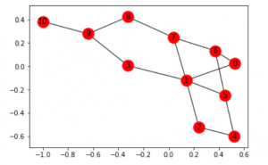
Note: The above graph may not look the same on reproduction of the code because the networkx library in python produces a random graph from the given edges.
Step 3: Defining the reward the system for the bot
MATRIX_SIZE = 11
M = np.matrix(np.ones(shape =(MATRIX_SIZE, MATRIX_SIZE)))
M *= -1

for point in edges:
print(point)
if point[1] == goal:
M[point] = 100
else:
M[point] = 0

if point[0] == goal:
M[point[::-1]] = 100
else:
M[point[::-1]]= 0
# reverse of point

M[goal, goal]= 100
print(M)
# add goal point round trip

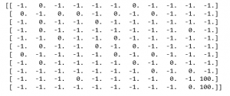
Step 4: Defining some utility functions to be used in the training
Q = np.matrix(np.zeros([MATRIX_SIZE, MATRIX_SIZE]))

gamma = 0.75
# learning parameter
initial_state = 1

# Determines the available actions for a given state
def available_actions(state):
current_state_row = M[state, ]
available_action = np.where(current_state_row >= 0)[1]
return available_action

available_action = available_actions(initial_state)

# Chooses one of the available actions at random
def sample_next_action(available_actions_range):
next_action = int(np.random.choice(available_action, 1))
return next_action

action = sample_next_action(available_action)

def update(current_state, action, gamma):

max_index = np.where(Q[action, ] == np.max(Q[action, ]))[1]
if max_index.shape[0] > 1:
max_index = int(np.random.choice(max_index, size = 1))
else:
max_index = int(max_index)
max_value = Q[action, max_index]
Q[current_state, action] = M[current_state, action] + gamma * max_value
if (np.max(Q) > 0):
return(np.sum(Q / np.max(Q)*100))
else:
return (0)
# Updates the Q-Matrix according to the path chosen

update(initial_state, action, gamma)

Step 5: Training and evaluating the bot using the Q-Matrix
scores = []
for i in range(1000):
current_state = np.random.randint(0, int(Q.shape[0]))
available_action = available_actions(current_state)
action = sample_next_action(available_action)
score = update(current_state, action, gamma)
scores.append(score)

# print("Trained Q matrix:")
# print(Q / np.max(Q)*100)
# You can uncomment the above two lines to view the trained Q matrix

# Testing
current_state = 0
steps = [current_state]

while current_state != 10:

next_step_index = np.where(Q[current_state, ] == np.max(Q[current_state, ]))[1]
if next_step_index.shape[0] > 1:
next_step_index = int(np.random.choice(next_step_index, size = 1))
else:
next_step_index = int(next_step_index)
steps.append(next_step_index)
current_state = next_step_index

print("Most efficient path:")
print(steps)

pl.plot(scores)
pl.xlabel('No of iterations')
pl.ylabel('Reward gained')
pl.show()

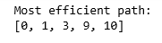
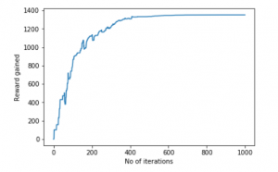

Now, Let’s bring this bot to a more realistic setting. Let us imagine that the bot is a detective and is trying to find out the location of a large drug racket. He naturally concludes that the drug sellers will not sell their products in a location which is known to be frequented by the police and the selling locations are near the location of the drug racket. Also, the sellers leave a trace of their products where they sell it and this can help the detective in finding out the required location. We want to train our bot to find the location using these Environmental Clues.
Step 6: Defining and visualizing the new graph with the environmental clues
# Defining the locations of the police and the drug traces
police = [2, 4, 5]
drug_traces = [3, 8, 9]

G = nx.Graph()
G.add_edges_from(edges)
mapping = {0:'0 - Detective', 1:'1', 2:'2 - Police', 3:'3 - Drug traces',
4:'4 - Police', 5:'5 - Police', 6:'6', 7:'7', 8:'Drug traces',
9:'9 - Drug traces', 10:'10 - Drug racket location'}

H = nx.relabel_nodes(G, mapping)
pos = nx.spring_layout(H)
nx.draw_networkx_nodes(H, pos, node_size =[200, 200, 200, 200, 200, 200, 200, 200])
nx.draw_networkx_edges(H, pos)
nx.draw_networkx_labels(H, pos)
pl.show()

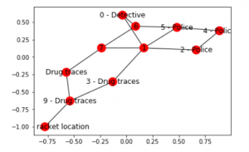
Note: The above graph may look a bit different from the previous graph but they, in fact, are the same graphs. This is due to the random placement of nodes by the networkx library.
Step 7: Defining some utility functions for the training process
Q = np.matrix(np.zeros([MATRIX_SIZE, MATRIX_SIZE]))
env_police = np.matrix(np.zeros([MATRIX_SIZE, MATRIX_SIZE]))
env_drugs = np.matrix(np.zeros([MATRIX_SIZE, MATRIX_SIZE]))
initial_state = 1

# Same as above
def available_actions(state):
current_state_row = M[state, ]
av_action = np.where(current_state_row >= 0)[1]
return av_action

# Same as above
def sample_next_action(available_actions_range):
next_action = int(np.random.choice(available_action, 1))
return next_action

# Exploring the environment
def collect_environmental_data(action):
found = []
if action in police:
found.append('p')
if action in drug_traces:
found.append('d')
return (found)

available_action = available_actions(initial_state)
action = sample_next_action(available_action)

def update(current_state, action, gamma):
max_index = np.where(Q[action, ] == np.max(Q[action, ]))[1]
if max_index.shape[0] > 1:
max_index = int(np.random.choice(max_index, size = 1))
else:
max_index = int(max_index)
max_value = Q[action, max_index]
Q[current_state, action] = M[current_state, action] + gamma * max_value
environment = collect_environmental_data(action)
if 'p' in environment:
env_police[current_state, action] += 1
if 'd' in environment:
env_drugs[current_state, action] += 1
if (np.max(Q) > 0):
return(np.sum(Q / np.max(Q)*100))
else:
return (0)
# Same as above
update(initial_state, action, gamma)

def available_actions_with_env_help(state):
current_state_row = M[state, ]
av_action = np.where(current_state_row >= 0)[1]

# if there are multiple routes, dis-favor anything negative
env_pos_row = env_matrix_snap[state, av_action]

if (np.sum(env_pos_row < 0)):
# can we remove the negative directions from av_act?
temp_av_action = av_action[np.array(env_pos_row)[0]>= 0]
if len(temp_av_action) > 0:
av_action = temp_av_action
return av_action
# Determines the available actions according to the environment

Step 8: Visualising the Environmental matrices
scores = []
for i in range(1000):
current_state = np.random.randint(0, int(Q.shape[0]))
available_action = available_actions(current_state)
action = sample_next_action(available_action)
score = update(current_state, action, gamma)

# print environmental matrices
print('Police Found')
print(env_police)
print('')
print('Drug traces Found')
print(env_drugs)

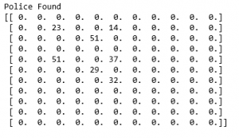
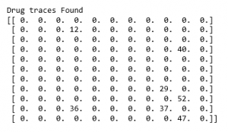
Step 9: Training and evaluating the model
scores = []
for i in range(1000):
current_state = np.random.randint(0, int(Q.shape[0]))
available_action = available_actions_with_env_help(current_state)
action = sample_next_action(available_action)
score = update(current_state, action, gamma)
scores.append(score)

pl.plot(scores)
pl.xlabel('Number of iterations')
pl.ylabel('Reward gained')
pl.show()

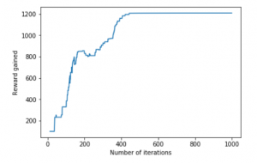
The example taken above was a very basic one and many practical examples like Self Driving Cars involve the concept of Game Theory.

Introduction to Thompson Sampling | Reinforcement Learning
- Difficulty Level : Hard
- Last Updated : 19 Oct, 2021
- Read
- Discuss
Reinforcement Learning is a branch of Machine Learning, also called Online Learning. It is used to decide what action to take at t+1 based on data up to time t. This concept is used in Artificial Intelligence applications such as walking. A popular example of reinforcement learning is a chess engine. Here, the agent decides upon a series of moves depending on the state of the board (the environment), and the reward can be defined as a win or lose at the end of the game.

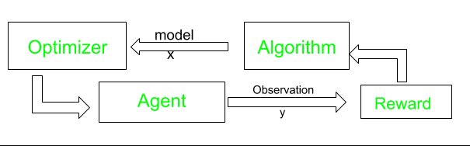
Thompson Sampling (Posterior Sampling or Probability Matching) is an algorithm for choosing the actions that address the exploration-exploitation dilemma in the multi-armed bandit problem. Actions are performed several times and are called exploration. It uses training information that evaluates the actions taken rather than instructs by giving correct actions. This is what creates the need for active exploration, for an explicit trial-and-error search for good behavior. Based on the results of those actions, rewards (1) or penalties (0) are given for that action to the machine. Further actions are performed in order to maximize the reward that may improve future performance. Suppose a robot has to pick several cans and put them in a container. Each time it puts the can to the container, it will memorize the steps followed and train itself to perform the task with better speed and precision (reward). If the Robot is not able to put the can in the container, it will not memorize that procedure (hence speed and performance will not improve) and will be considered as a penalty.

Thompson Sampling has the advantage of the tendency to decrease the search as we get more and more information, which mimics the desirable trade-off in the problem, where we want as much information as possible in fewer searches. Hence, this Algorithm has a tendency to be more “search-oriented” when we have fewer data and less “search-oriented” when we have a lot of data.
Multi-Armed Bandit Problem
Multi-armed Bandit is synonymous with a slot machine with many arms. Each action selection is like a play of one of the slot machine’s levers, and the rewards are the payoffs for hitting the jackpot. Through repeated action selections you are to maximize your winnings by concentrating your actions on the best levers. Each machine provides a different reward from a probability distribution over the mean reward specific to the machine. Without knowing these probabilities, the gambler has to maximize the sum of reward earned through a sequence of arms pull. If you maintain estimates of the action values, then at any time step there is at least one action whose estimated value is greatest. We call this a greedy action. The analogy to this problem can be advertisements displayed whenever the user visits a webpage. Arms are ads displayed to the users each time they connect to a web page. Each time a user connects to the page makes around. At each round, we choose one ad to display to the user. At each round n, ad I gives reward ri(n) ε {0, 1}: ri(n)=1 if the user clicked on the ad i, 0 if the user didn’t. The goal of the algorithm will be to maximize the reward. Another analogy is that of a doctor choosing between experimental treatments for a series of seriously ill patients. Each action selection is a treatment selection, and each reward is the survival or well-being of the patient.
Algorithm
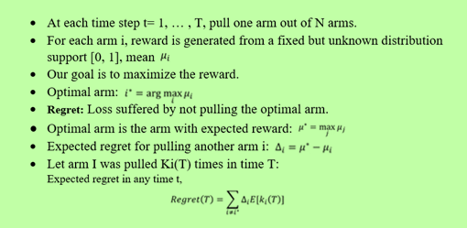
Some Practical Applications
- Netflix Item based recommender systems: Images related to movies/shows are shown to users in such a way that they are more likely to watch it.
- Bidding and Stock Exchange: Predicting Stocks based on Current data of stock prices.
- Traffic Light Control: Predicting the delay in the signal.
- Automation in Industries: Bots and Machines for transporting and Delivering items without human intervention.

Previous
Upper Confidence Bound Algorithm in Reinforcement Learning
Next
Implementation of K Nearest Neighbors
Recommended Articles
Page :
1
2
3
ML | Reinforcement Learning Algorithm : Python Implementation using Q-learning
30, May 19
Neural Logic Reinforcement Learning - An Introduction
12, Jan 20
Genetic Algorithm for Reinforcement Learning : Python implementation
31, May 19
SARSA Reinforcement Learning
14, Jun 19
Upper Confidence Bound Algorithm in Reinforcement Learning
08, Feb 20
Expected SARSA in Reinforcement Learning
31, Aug 20
Sparse Rewards in Reinforcement Learning
19, Apr 22
Understanding Reinforcement Learning in-depth
19, Feb 22
Reinforcement learning
25, Apr 18
Epsilon-Greedy Algorithm in Reinforcement Learning
01, May 20
DLSS - Deep Learning Super Sampling
23, Jun 20
Introduction to Multi-Task Learning(MTL) for Deep Learning
14, Nov 18
Sampling distribution Using Python
26, Oct 22
Artificial intelligence vs Machine Learning vs Deep Learning
23, Jan 19
Learning to learn Artificial Intelligence | An overview of Meta-Learning
18, May 19
Difference Between Artificial Intelligence vs Machine Learning vs Deep Learning
01, May 20
Need of Data Structures and Algorithms for Deep Learning and Machine Learning
14, Oct 20
Collaborative Learning - Federated Learning
20, Jan 21
Fusion Learning - The One Shot Federated Learning
20, Jan 21
ML | Types of Learning – Supervised Learning
01, May 18
How to Start Learning Machine Learning?
11, Sep 19
Learning Model Building in Scikit-learn : A Python Machine Learning Library
17, Feb 17
Introduction to Deep Learning
01, Jun 18
Deep Learning | Introduction to Long Short Term Memory
16, Jan 19
Article Contributed By :
Prateek_Aggarwal
@Prateek_Aggarwal
Vote for difficulty
Current difficulty : Hard
Improved By :
- Pushpender007
Article Tags :
- Artificial Intelligence
- Machine Learning
Practice Tags :
- Machine Learning

Report Issue
Data Structures & Algorithms- Self Paced Course
View Details
AD

AD

What's New

Machine Learning Foundation - Self Paced
View Details
Complete Interview Preparation- Self Paced Course
View Details

AD

AD

AD

Genetic Algorithm for Reinforcement Learning : Python implementation
- Last Updated : 07 Jun, 2019
- Read
- Discuss
Most beginners in Machine Learning start with learning Supervised Learning techniques such as classification and regression. However, one of the most important paradigms in Machine Learning is Reinforcement Learning (RL) which is able to tackle many challenging tasks. It is an aspect of Machine learning where an agent learns to behave in an environment, by performing certain actions and observing the rewards(results) which it gets from those actions.
In Reinforcement Learning, we give the machines a few inputs and actions, and then, reward them based on the output. Reward maximization is the end goal. It is just like a little baby who knows nothing at first is left alone in an environment and then after a little understanding tends to know things around itself.

Here, we are just going to build an algorithm based on the genetic mutation of a population when attacked by a virus. In the first generation of our population only a few fittest ones will be able to survive, whereas as the generations will pass, the new generations will be much stronger against the virus than their ancestors. It is a basic algorithm which just gives an idea of how these things work. Anyone with the basic knowledge of python and some libraries like numpy, matplotlib, etc can easily understand this code. This is just for the introduction and to provide the surface level knowledge about Reinforcement Learning.

Genetic Algorithm –
Libraries Used:

- numpy : we’ll be using numpy arrays and other basic calculation functionalities from this library
- matplotlib : we’ll be using matplotlib.pyplot functionality in order to plot the graphs for the visual understanding of the algorithm.
In this program, we’ll define 3 main functions in order to generate the next generation of the population which is genetically more powerful than the previous ones.
The three main functions used are:
populate: This is used to generate the population and then appending it to a list. This function accepts the attributes like the number of features in the population and the size of it.
reduction: This function is used to reduce the size of the population and allows only the 100 most fittest ones to survive. These fit ones will be the ones used to generate the next generation of the population.
cross: This function is used for the process of cross-breeding between the ones that are left in order to generate a whole new generation of the population which will be much more immune towards the virus.

Below is the implementation –
import numpy as np
import matplotlib.pyplot as plt

# specifying the size for each and
# every matplotlib plot globally
plt.rcParams['figure.figsize'] = [8, 6]

# defining list objects with range of the graph
x1_range = [-100, 100]
x2_range = [-100, 100]

# empty list object to store the population
population = []

# this function is used to generate the population
# and appending it to the population list defined above
# it takes the attributes as no. of features in a
# population and size that we have in it
def populate(features, size = 1000):

# here we are defining the coordinate
# for each entity in a population
initial = []

for _ in range(size):
entity = []
for feature in features:

# this * feature variable unpacks a list
# or tuple into position arguments.
val = np.random.randint(*feature)
entity.append(val)
initial.append(entity)

return np.array(initial)

# defining the virus in the form of numpy array
virus = np.array([5, 5])

# only the 100 fit ones will survive in this one
def fitness(population, virus, size = 100):

scores = []

# enumerate also provides the index as for the iterator
for index, entity in enumerate(population):
score = np.sum((entity-virus)**2)
scores.append((score, index))

scores = sorted(scores)[:size]

return np.array(scores)[:, 1]

# this function is used to plot the graph
def draw(population, virus):
plt.xlim((-100, 100))
plt.ylim((-100, 100))
plt.scatter(population[:, 0], population[:, 1], c ='green', s = 12)
plt.scatter(virus[0], virus[1], c ='red', s = 60)

def reduction(population, virus, size = 100):

# only the index of the fittest ones
# is returned in sorted format
fittest = fitness(population, virus, size)

new_pop = []

for item in fittest:
new_pop.append(population[item])

return np.array(new_pop)

# cross mutation in order to generate the next generation
# of the population which will be more immune to virus than previous
def cross(population, size = 1000):

new_pop = []

for _ in range(size):
p = population[np.random.randint(0, len(population))]
m = population[np.random.randint(0, len(population))]

# we are only considering half of each
# without considering random selection
entity = []
entity.append(*p[:len(p)//2])
entity.append(*m[len(m)//2:])

new_pop.append(entity)

return np.array(new_pop)

# generating and adding the random features to
# the entity so that it looks more distributed
def mutate(population):

return population + np.random.randint(-10, 10, 2000).reshape(1000, 2)

# the complete cycle of the above steps
population = populate([x1_range, x2_range], 1000)

# gens is the number of generation
def cycle(population, virus, gens = 1):

# if we change the value of gens, we'll get
# next and genetically more powerful generation
# of the population
for _ in range(gens):
population = reduction(population, virus, 100)
population = cross(population, 1000)
population = mutate(population)

return population

population = cycle(population, virus)

draw(population, virus)

Output:
1) For generation 1, when gens=0
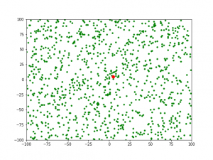
2) For generation 2, when gens=1
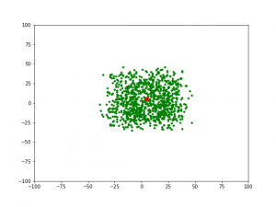
3) For generation 3, when gens=2
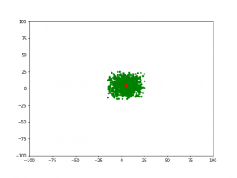

Previous
Python | Single Point Crossover in Genetic Algorithm
Next
Implementation of K Nearest Neighbors
Recommended Articles
Page :
1
2
3
ML | Reinforcement Learning Algorithm : Python Implementation using Q-learning
30, May 19
Upper Confidence Bound Algorithm in Reinforcement Learning
08, Feb 20
Epsilon-Greedy Algorithm in Reinforcement Learning
01, May 20
Python | Single Point Crossover in Genetic Algorithm
11, Oct 19
SARSA Reinforcement Learning
14, Jun 19
Introduction to Thompson Sampling | Reinforcement Learning
22, Aug 19
Neural Logic Reinforcement Learning - An Introduction
12, Jan 20
Expected SARSA in Reinforcement Learning
31, Aug 20
Sparse Rewards in Reinforcement Learning
19, Apr 22
Understanding Reinforcement Learning in-depth
19, Feb 22
Reinforcement learning
25, Apr 18
Simple Genetic Algorithm (SGA)
01, Apr 21
Encoding Methods in Genetic Algorithm
17, Jun 19
Crossover in Genetic Algorithm
21, Jun 19
Steady State Genetic Algorithm (SSGA)
01, Apr 21
ML - Convergence of Genetic Algorithms
09, Jun 20
Learning Model Building in Scikit-learn : A Python Machine Learning Library
17, Feb 17
Hebbian Learning Rule with Implementation of AND Gate
25, Nov 20
Implementation of Teaching Learning Based Optimization
18, Jul 21
Introduction to Multi-Task Learning(MTL) for Deep Learning
14, Nov 18
Artificial intelligence vs Machine Learning vs Deep Learning
23, Jan 19
Learning to learn Artificial Intelligence | An overview of Meta-Learning
18, May 19
Difference Between Artificial Intelligence vs Machine Learning vs Deep Learning
01, May 20
Need of Data Structures and Algorithms for Deep Learning and Machine Learning
14, Oct 20
Article Contributed By :
ngrover241
@ngrover241
Vote for difficulty
Article Tags :
- Machine Learning
Practice Tags :
- Machine Learning

Report Issue
Data Structures & Algorithms- Self Paced Course
View Details
AD

AD

What's New

Machine Learning Foundation - Self Paced
View Details
Complete Interview Preparation- Self Paced Course
View Details

AD

AD

AD

SARSA Reinforcement Learning
- Difficulty Level : Medium
- Last Updated : 24 Jun, 2021
- Read
- Discuss
Prerequisites: Q-Learning technique
SARSA algorithm is a slight variation of the popular Q-Learning algorithm. For a learning agent in any Reinforcement Learning algorithm it’s policy can be of two types:-
- On Policy: In this, the learning agent learns the value function according to the current action derived from the policy currently being used.
- Off Policy: In this, the learning agent learns the value function according to the action derived from another policy.
Q-Learning technique is an Off Policy technique and uses the greedy approach to learn the Q-value. SARSA technique, on the other hand, is an On Policy and uses the action performed by the current policy to learn the Q-value.
This difference is visible in the difference of the update statements for each technique:-

- Q-Learning:
- SARSA:
Here, the update equation for SARSA depends on the current state, current action, reward obtained, next state and next action. This observation lead to the naming of the learning technique as SARSA stands for State Action Reward State Action which symbolizes the tuple (s, a, r, s’, a’).
The following Python code demonstrates how to implement the SARSA algorithm using the OpenAI’s gym module to load the environment.
Step 1: Importing the required libraries

import numpy as np
import gym

Step 2: Building the environment
Here, we will be using the ‘FrozenLake-v0’ environment which is preloaded into gym. You can read about the environment description here.

#Building the environment
env = gym.make('FrozenLake-v0')

Step 3: Initializing different parameters

#Defining the different parameters
epsilon = 0.9
total_episodes = 10000
max_steps = 100
alpha = 0.85
gamma = 0.95

#Initializing the Q-matrix
Q = np.zeros((env.observation_space.n, env.action_space.n))

Step 4: Defining utility functions to be used in the learning process

#Function to choose the next action
def choose_action(state):
action=0
if np.random.uniform(0, 1) < epsilon:
action = env.action_space.sample()
else:
action = np.argmax(Q[state, :])
return action

#Function to learn the Q-value
def update(state, state2, reward, action, action2):
predict = Q[state, action]
target = reward + gamma * Q[state2, action2]
Q[state, action] = Q[state, action] + alpha * (target - predict)

Step 5: Training the learning agent

#Initializing the reward
reward=0

# Starting the SARSA learning
for episode in range(total_episodes):
t = 0
state1 = env.reset()
action1 = choose_action(state1)

while t < max_steps:
#Visualizing the training
env.render()

#Getting the next state
state2, reward, done, info = env.step(action1)

#Choosing the next action
action2 = choose_action(state2)

#Learning the Q-value
update(state1, state2, reward, action1, action2)

state1 = state2
action1 = action2

#Updating the respective vaLues
t += 1
reward += 1

#If at the end of learning process
if done:
break

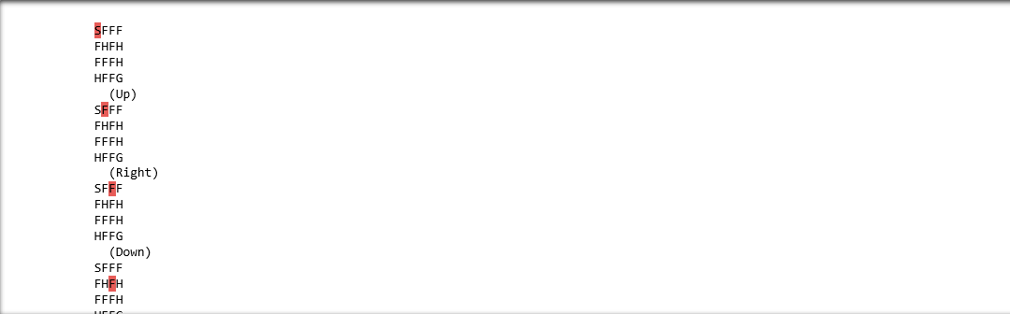
In the above output, the red mark determines the current position of the agent in the environment while the direction given in brackets gives the direction of movement that the agent will make next. Note that the agent stays at it’s position if goes out of bounds.
Step 6: Evaluating the performance

#Evaluating the performance
print ("Performance : ", reward/total_episodes)

#Visualizing the Q-matrix
print(Q)

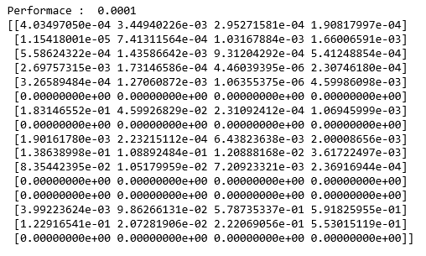

Previous
Python IMDbPY – Getting person ID from searched persons
Next
numpy.rate() in Python
Recommended Articles
Page :
1
2
3
Expected SARSA in Reinforcement Learning
31, Aug 20
ML | Reinforcement Learning Algorithm : Python Implementation using Q-learning
30, May 19
Genetic Algorithm for Reinforcement Learning : Python implementation
31, May 19
Introduction to Thompson Sampling | Reinforcement Learning
22, Aug 19
Neural Logic Reinforcement Learning - An Introduction
12, Jan 20
Upper Confidence Bound Algorithm in Reinforcement Learning
08, Feb 20
Sparse Rewards in Reinforcement Learning
19, Apr 22
Understanding Reinforcement Learning in-depth
19, Feb 22
Reinforcement learning
25, Apr 18
Epsilon-Greedy Algorithm in Reinforcement Learning
01, May 20
Introduction to Multi-Task Learning(MTL) for Deep Learning
14, Nov 18
Artificial intelligence vs Machine Learning vs Deep Learning
23, Jan 19
Learning to learn Artificial Intelligence | An overview of Meta-Learning
18, May 19
Difference Between Artificial Intelligence vs Machine Learning vs Deep Learning
01, May 20
Need of Data Structures and Algorithms for Deep Learning and Machine Learning
14, Oct 20
Collaborative Learning - Federated Learning
20, Jan 21
Fusion Learning - The One Shot Federated Learning
20, Jan 21
ML | Types of Learning – Supervised Learning
01, May 18
How to Start Learning Machine Learning?
11, Sep 19
Learning Model Building in Scikit-learn : A Python Machine Learning Library
17, Feb 17
Demystifying Machine Learning
02, May 16
Cross Validation in Machine Learning
21, Nov 17
How To Use Classification Machine Learning Algorithms in Weka ?
04, May 21
Support vector machine in Machine Learning
20, Dec 20
Article Contributed By :
AlindGupta
@AlindGupta
Vote for difficulty
Current difficulty : Medium
Improved By :
- rajeev0719singh
Article Tags :
- Machine Learning
- Python
Practice Tags :
- Machine Learning
- python

Report Issue
Data Structures & Algorithms- Self Paced Course
View Details
AD

AD

What's New


Python Programming Foundation -Self Paced Course
View Details
Complete Interview Preparation- Self Paced Course
View Details

AD

AD

AD

Q-Learning in Python
- Difficulty Level : Expert
- Last Updated : 24 Aug, 2022
Q, stats = qLearning(env, 1000)
Step #6 : Plot important statistics.
plotting.plot_episode_stats(stats)

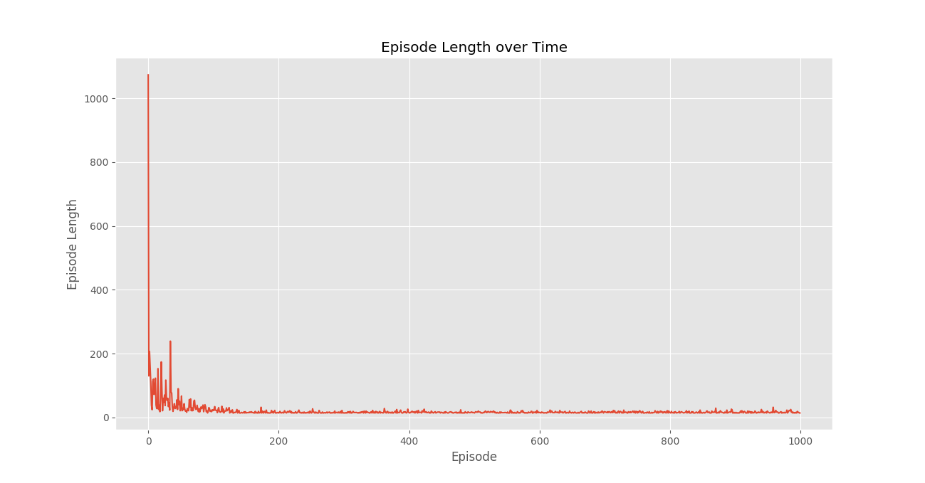
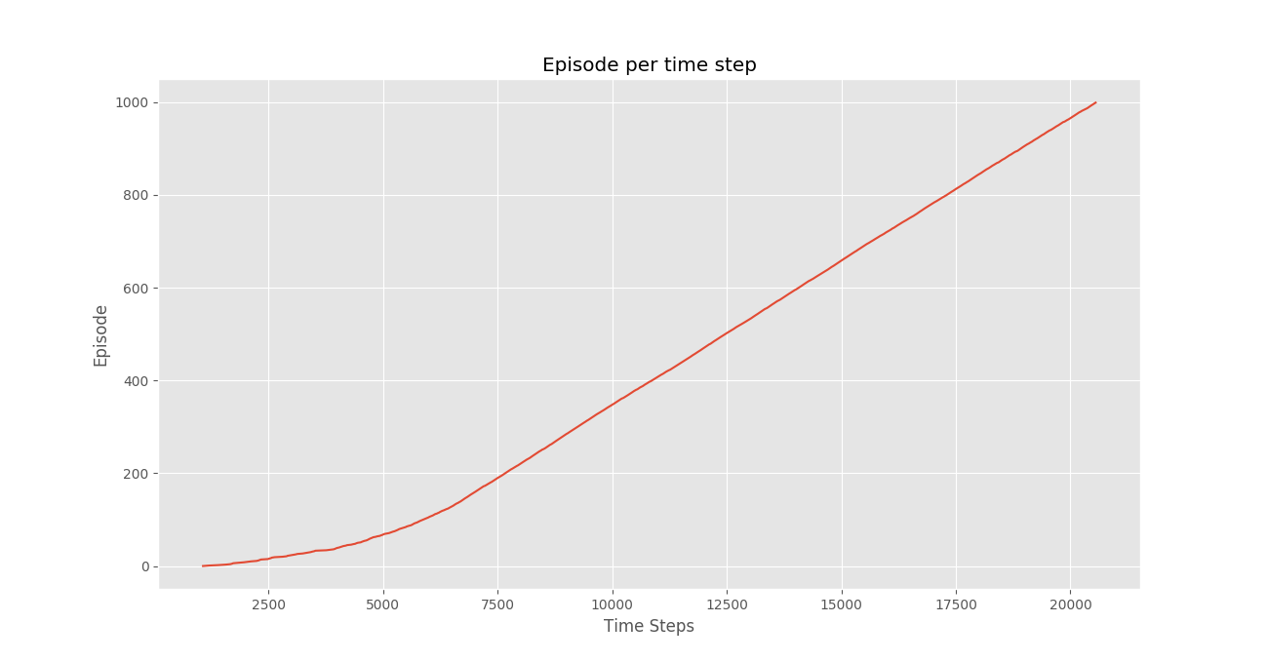
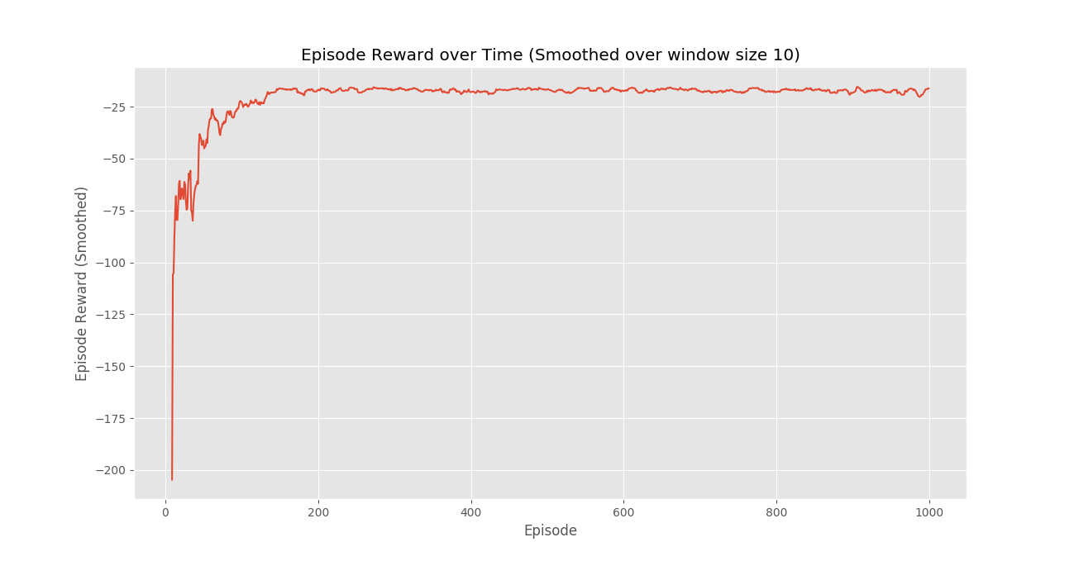
Conclusion:
We see that in the Episode Reward over time plot that the episode rewards progressively increase over time and ultimately levels out at a high reward per episode value which indicates that the agent has learnt to maximize its total reward earned in an episode by behaving optimally at every state.

Previous
Deep Q-Learning
Next
Implementation of K Nearest Neighbors
Recommended Articles
Page :
1
2
3
Important differences between Python 2.x and Python 3.x with examples
25, Feb 16
Python | Merge Python key values to list
31, Jul 19
Reading Python File-Like Objects from C | Python
06, Jun 19
Python | Add Logging to a Python Script
11, Jun 19
Python | Add Logging to Python Libraries
11, Jun 19
JavaScript vs Python : Can Python Overtop JavaScript by 2020?
12, Jun 19
Python | Visualizing O(n) using Python
17, Aug 19
Python | Index of Non-Zero elements in Python list
02, Sep 19
Python | Convert list to Python array
26, Sep 19
MySQL-Connector-Python module in Python
04, Mar 20
Python - Read blob object in python using wand library
21, Apr 20
Python | PRAW - Python Reddit API Wrapper
26, Apr 20
twitter-text-python (ttp) module - Python
28, May 20
Reusable piece of python functionality for wrapping arbitrary blocks of code : Python Context Managers
31, Jul 20
Python program to check if the list contains three consecutive common numbers in Python
13, Aug 20
Creating and updating PowerPoint Presentations in Python using python - pptx
15, Aug 20
Filter Python list by Predicate in Python
16, Dec 21
Python: Iterating With Python Lambda
16, Dec 21
Python | Set 4 (Dictionary, Keywords in Python)
09, Feb 16
Python program to build flashcard using class in Python
03, Jan 21
GeeksforGeeks Python Foundation Course - Learn Python in Hindi!
28, Oct 21
Python | Sort Python Dictionaries by Key or Value
24, Jul 18
What is Python Used For? | 7 Practical Python Applications
26, Sep 22
Python Debugger – Python pdb
02, Jan 21
Article Contributed By :

Kaustav kumar Chanda
@Kaustav kumar Chanda
Vote for difficulty
Current difficulty : Expert
Improved By :
- VishvajeetRamanuj
- rajeev0719singh
Article Tags :
- Advanced Computer Subject
- Machine Learning
- Python
Practice Tags :
- Machine Learning
- python

Report Issue
Data Structures & Algorithms- Self Paced Course
View Details
AD

AD

What's New

Python Programming Foundation -Self Paced Course
View Details
Complete Interview Preparation- Self Paced Course
View Details

AD

AD

AD

- Read
- Discuss
Pre-Requisite : Reinforcement Learning
Reinforcement Learning briefly is a paradigm of Learning Process in which a learning agent learns, overtime, to behave optimally in a certain environment by interacting continuously in the environment. The agent during its course of learning experience various different situations in the environment it is in. These are called states. The agent while being in that state may choose from a set of allowable actions which may fetch different rewards(or penalties). The learning agent overtime learns to maximize these rewards so as to behave optimally at any given state it is in.
Q-Learning is a basic form of Reinforcement Learning which uses Q-values (also called action values) to iteratively improve the behavior of the learning agent.
- Q-Values or Action-Values: Q-values are defined for states and actions. is an estimation of how good is it to take the action at the state . This estimation of will be iteratively computed using the TD- Update rule which we will see in the upcoming sections.
- Rewards and Episodes: An agent over the course of its lifetime starts from a start state, makes a number of transitions from its current state to a next state based on its choice of action and also the environment the agent is interacting in. At every step of transition, the agent from a state takes an action, observes a reward from the environment, and then transits to another state. If at any point of time the agent ends up in one of the terminating states that means there are no further transition possible. This is said to be the completion of an episode.
- Temporal Difference or TD-Update:
The Temporal Difference or TD-Update rule can be represented as follows :
This update rule to estimate the value of Q is applied at every time step of the agents interaction with the environment. The terms used are explained below. :
  - : Current State of the agent.
  - : Current Action Picked according to some policy.
  - : Next State where the agent ends up.
  - : Next best action to be picked using current Q-value estimation, i.e. pick the action with the maximum Q-value in the next state.
  - : Current Reward observed from the environment in Response of current action.
  - (>0 and <=1) : Discounting Factor for Future Rewards. Future rewards are less valuable than current rewards so they must be discounted. Since Q-value is an estimation of expected rewards from a state, discounting rule applies here as well.
  - : Step length taken to update the estimation of Q(S, A).
- Choosing the Action to take using -greedy policy:
-greedy policy of is a very simple policy of choosing actions using the current Q-value estimations. It goes as follows :
  - With probability choose the action which has the highest Q-value.
  - With probability choose any action at random.
Now with all the theory required in hand let us take an example. We will use OpenAI’s gym environment to train our Q-Learning model.
Command to Install gym –
pip install gym
Before starting with example, you will need some helper code in order to visualize the working of the algorithms. There will be two helper files which need to be downloaded in the working directory. One can find the files here.
Step # 1 : Import required libraries.
import gym
import itertools
import matplotlib
import matplotlib.style
import numpy as np
import pandas as pd
import sys

from collections import defaultdict
from windy_gridworld import WindyGridworldEnv
import plotting

matplotlib.style.use('ggplot')

Step #2 : Create gym environment.
env = WindyGridworldEnv()

Step #3 : Make the -greedy policy.
def createEpsilonGreedyPolicy(Q, epsilon, num_actions):
"""
Creates an epsilon-greedy policy based
on a given Q-function and epsilon.

Returns a function that takes the state
as an input and returns the probabilities
for each action in the form of a numpy array
of length of the action space(set of possible actions).
"""
def policyFunction(state):

Action_probabilities = np.ones(num_actions,
dtype = float) * epsilon / num_actions

best_action = np.argmax(Q[state])
Action_probabilities[best_action] += (1.0 - epsilon)
return Action_probabilities

return policyFunction

Step #4 : Build Q-Learning Model.
def qLearning(env, num_episodes, discount_factor = 1.0,
alpha = 0.6, epsilon = 0.1):
"""
Q-Learning algorithm: Off-policy TD control.
Finds the optimal greedy policy while improving
following an epsilon-greedy policy"""

# Action value function
# A nested dictionary that maps
# state -> (action -> action-value).
Q = defaultdict(lambda: np.zeros(env.action_space.n))

# Keeps track of useful statistics
stats = plotting.EpisodeStats(
episode_lengths = np.zeros(num_episodes),
episode_rewards = np.zeros(num_episodes))

# Create an epsilon greedy policy function
# appropriately for environment action space
policy = createEpsilonGreedyPolicy(Q, epsilon, env.action_space.n)

# For every episode
for ith_episode in range(num_episodes):

# Reset the environment and pick the first action
state = env.reset()

for t in itertools.count():

# get probabilities of all actions from current state
action_probabilities = policy(state)

# choose action according to
# the probability distribution
action = np.random.choice(np.arange(
len(action_probabilities)),
p = action_probabilities)

# take action and get reward, transit to next state
next_state, reward, done, _ = env.step(action)

# Update statistics
stats.episode_rewards[ith_episode] += reward
stats.episode_lengths[ith_episode] = t

# TD Update
best_next_action = np.argmax(Q[next_state])
td_target = reward + discount_factor * Q[next_state][best_next_action]
td_delta = td_target - Q[state][action]
Q[state][action] += alpha * td_delta

# done is True if episode terminated
if done:
break

state = next_state

return Q, stats

Step #5 : Train the model.

